CRITERION 6 | Facilities And Technical Support | 100

6.1. Availability of adequate, well-equipped classrooms to meet the curriculum requirements (10)

Department of Computer engineering at Government residential women's polytechnic has adequate number of classrooms. These classrooms are Spacious and well-ventilated. Basic facilities like desks, electricity supply, lanterns, fans, green-boards etc are sufficient in numbers in each classroom. All these classrooms are utilized for engaging lectures and tutorials. Below mentioned, Table 1 gives quick overview of classrooms, facilities available and utilization purpose of classrooms. All classrooms are exclusively used by computer engineering department.

Table 1 : List of Classrooms and facilities
Sr No | Class Room Name | Used By | Area (Sq. M) | Capacity to Sit Students | Available Furniture / Facility |  |  |  |  | Utilization Purpose
 |  |  |  |  | Desks | lantern | Fans | Type Of Board | LAN Facility | Utilization Purpose
1 | Room 3 | First Year Students | 56.6 | 60+ | 30 | 7 | 5 | Green Board | Yes | Lectures and Tutorials
2 | Room 4 | Second Year Students | 56.6 | 60+ | 30 | 7 | 5 | Green Board | Yes | Lectures and Tutorials
3 | Drawing Hall | Third Year Students | 154.06 | 125+ | 62 | 15 | 12 | Green Board | Yes | Lectures and Tutorials

6.2. Availability of adequate and well-equipped workshops, Laboratories and Technical manpower to meet the curriculum requirements (40)
A. Adequacy (10)
B. Quality of Labs/workshop (20)
C. Technical Manpower support –Eligible and Adequate (10)

A. Adequacy (10)
Computer engineering Program at Government residential women's polytechnic Latur, is having total 5 number of laboratories which are exclusively used by students and teachers of this program. The laboratories are hosting almost 20+ number of computers in each. These computers are very newly purchased and provided by Directorate of technical education mumbai in 2019. Almost all computers in each laboratory are with very new and high configuration i.e i3,i5 processors and 4GB,8GB of RAM. Table 3, mentioned on-next-page, gives insights of Laboratory names, their utilizations, equipments and nature of utilization. Apart from five exclusive laboratories of computer engineering program, the Physics and chemistry laboratories are also used on shared utilization basis.
Every laboratory has exclusive computing facility, furniture, independent infrastructure as well as good seating arrangements for students, leading to quality learning experience for students.
B. Quality of Labs/workshop (20)
Learning by doing can only be achieved when students work in laboratory. Here at Computer engineering program, All five laboratories are having very good quality of resources. These computing resources, technological facilities, infrastructural facilities etc are very much adequate in number as well as in quality. Along with, advanced latest configuration of computing hardware, very newly introduced software packages like Windows 10 Operating system, Java Packages etc are installed in computers. The combination of modern hardware and software makes students learning by doing more effective. The information in tables on next few pages gives clear indication that all computing resources, equipments and facilities are of very high quality and very much adequate in number for performing practical and workshop practices.
Apart from above mentioned facilities in laboratory, All computers in each one of five labs and four faculty rooms are well connected to Internet. All these computers are also connected to each other in local area network(LAN) with configurable switch available at seating room of Head of Computer engineering program.
The hardware equipments required for course Workshop practice are available in dedicated hardware laboratory. Following table shows available hardware equipments in computer workshop.
Table 2 : Availability of hardware equipments in Computer Workshop
Sr No | Name of Laboratory | Area (Sq. M) | Batch Size | Name of Important Equipments | Technical Manpower Support |  |  | Remark
 |  |  |  | Hardware | Name Of Technical Staff | Designation | Qualification | Remark
1 | Hardware Laboratory | 95.94 | 20 | Personal Computer, Mother board Kit, | Ku. N D Hishobe | Technical Lab. Assistant | I.T.I-Elec | Exclusive use
 |  |  |  | HDD Drives
 |  |  |  | USB and PS2 Keyboard and Mouse
 |  |  |  | CPU, LAN Cables, RJ 45 Connector etc

Apart from above mentioned technical facilities, basic facilities like Notice boards in open porch, White board and green notice board in laboratory, Shoe racks outside each laboratory etc are provided for students. Utmost cleanliness and hygiene is maintained not only in laboratory but each classroom, drawing hall, workshop, faculty room, open porch.
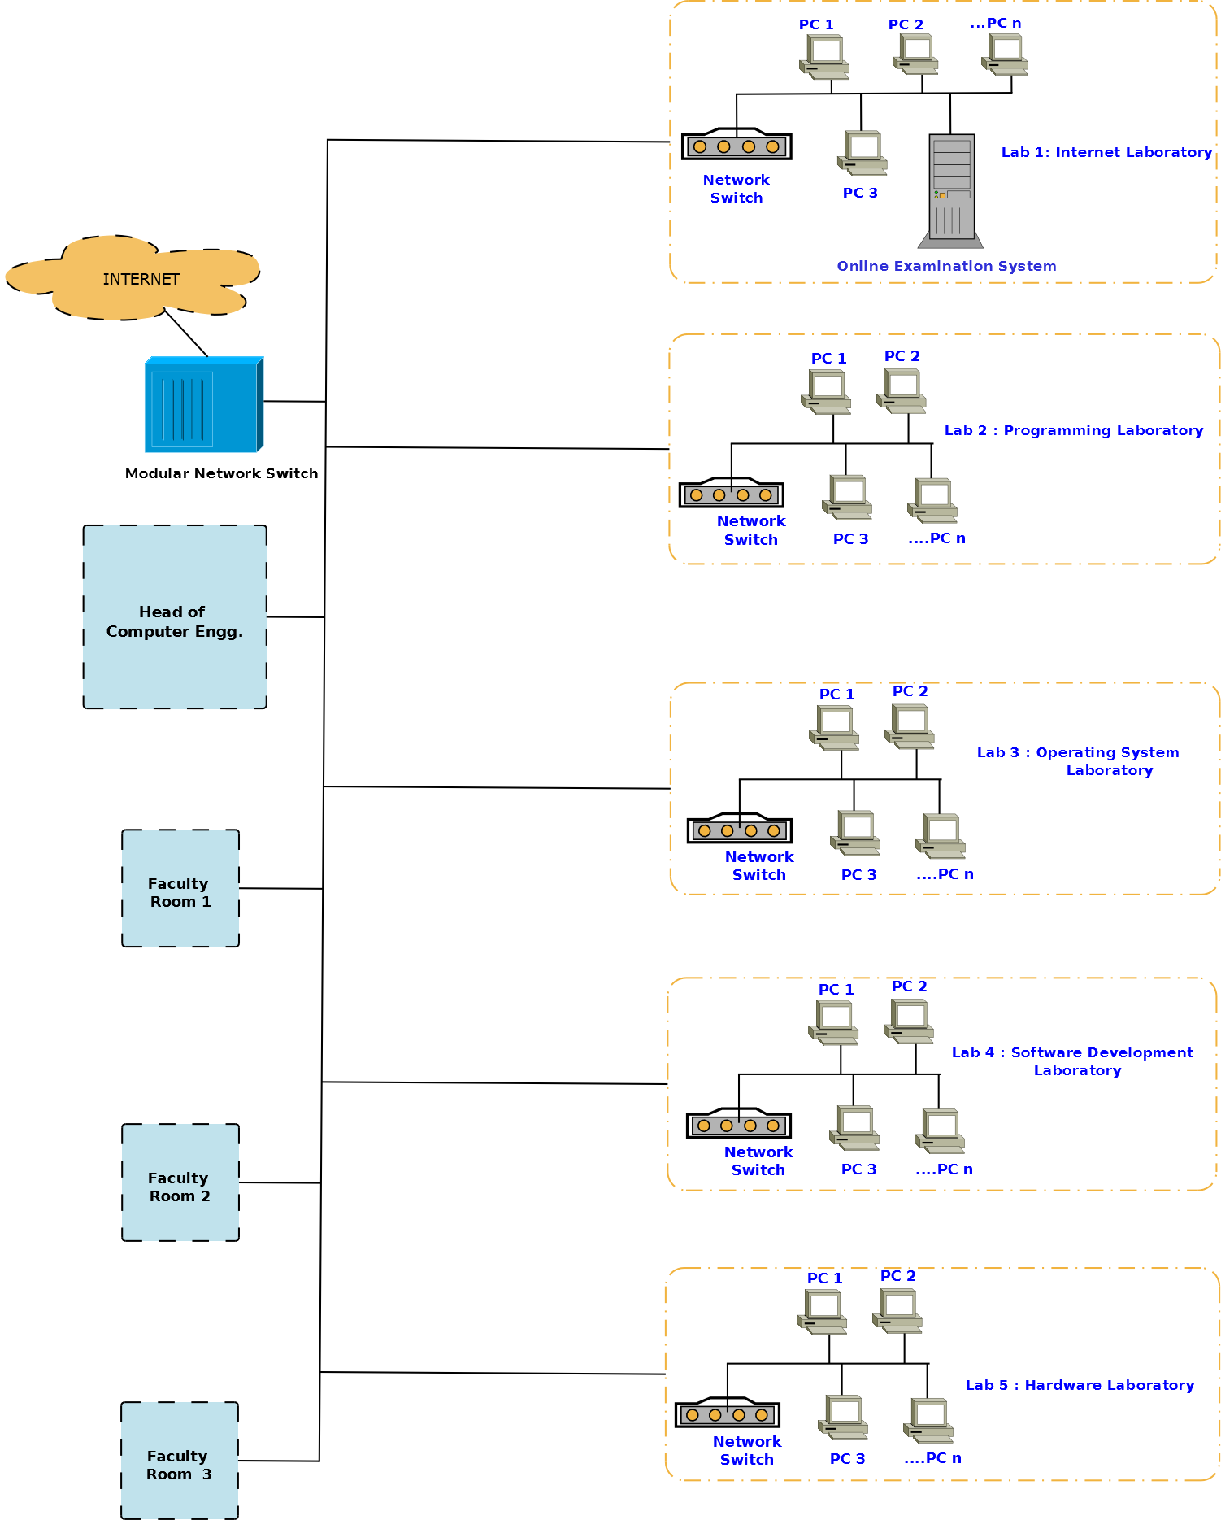
Figure 1 : Network Layout and Logical Arrangement of Laboratories in Computer Engg. Program
Figure 1 shows the Leased Line based Internet Facility created at computer engineering department. All laboratories have active Internet connection given from Modular network switch. Each laboratory of five laboratories have independent switch. This switch can be used for providing internet connectivity to each computer in laboratory. In addition to internet connection to laboratory, 1 HoD Cabin and 3 faculty room also have direct internet connection from Modular network switch.
Table 3 : List of Laboratories
Sr No | Name of Laboratory | No of Students per Setup(Batch Size) | Name of Important Equipments |  | Weekly Utilization Status (Name of Courses for which Lab is utilized) | Technical Manpower Support |  |  | Remark
Sr No | Name of Laboratory | No of Students per Setup(Batch Size) | Computers/Hardware | Quantity |  | Name Of Technical Staff | Designation | Qualification | Remark
1 | Internet Laboratory | 20 | Dell Desktop PC : i3-P-100 /4GB Ram/Win-10 PRO | 20 | STE, GAD, ACN, | Ku. N D Hishobe | Technical Lab. Assistant | I.T.I-Elec | Exclusive use
2 | Programming Laboratory | 20 | HP-Desktop PC i5 : Intel core i5-8400, 8GB | 20 | DMS,DCC,CPP, | Ku. N D Hishobe | Technical Lab. Assistant | I.T.I-Elec | Exclusive use
3 | Operating System Laboratory | 20 | Lenovo desktop PC (15)+ HP-280-G3 Desktop PC i5(05) | 20 | DSU, CGR,AMI,MIC, SEN, OSY | Ku. N D Hishobe | Technical Lab. Assistant | I.T.I-Elec | Exclusive use
4 | Software Development Laboratory | 20 | Lenovo desktop PC (14)+ Acer Desktop PC | 20 | OOP,AJP, LPR,JPR, | Ku. N D Hishobe | Technical Lab. Assistant | I.T.I-Elec | Exclusive use
5 | Hardware Laboratory | 20 | Personal Computer, Mother board Kit etc | - | Workshop Practice, CPH, CHM | Ku. N D Hishobe | Technical Lab. Assistant | I.T.I-Elec | Exclusive use
6 | Physics Laboratory | 20 | Personal computer for faculty use | 02 | Basic Science Physics | V G Lagdive | Non-Technical Lab Assistant | B.Sc | Shared use
7 | Chemistry Laboratory | 20 | Nil | Nil | Basic Science Chemistry | V G Lagdive | Non-Technical Lab Assistant | B.Sc | Shared use

Table 4 : Adequacy of furniture and other facilities in Laboratories
Sr no | Laboratory Name / Faculty Room | Area (Sq. M) | Capacity to Sit Students | Available Furniture / Facility
 |  |  |  | Computer Tables | Tube-lights | Fans | Number / Type Of Board | Chairs
1 | Internet Laboratory | 95.94 | 20 | 19 | 8 | 5 | 02/Green Board | 25
2 | Programming Laboratory | 95.94 | 20 | 16 | 9 | 6 | Green Board | 20
3 | Operating System Laboratory | 95.94 | 20 | 16 | 7 | 6 | Green Board | 20
4 | Software Development Laboratory | 96.23 | 20 | 14 | 9 | 6 | NIL | 20
5 | Hardware Laboratory | 95.94 | 20 | 6 | 9 | 6 | Green Board | 20

C. Technical Manpower support –Eligible and Adequate (10)
Below mentioned self-explanatory table shows availability of technical manpower supporting staff, their educational qualifications and designation.
Table 5 : Technical manpower
Sr no | Name of Technical Person | Designation | Qualification | Experience (Yrs)
1 | Shri S V Chavan | I/C Head of Computer Engineering | M.E | 31
2 | Ku R D Kasar | Lecturer in Computer Engineering | M.tech | 16
3 | Ku M G Mulge | Lecturer in Computer Engineering | M.tech | 15
4 | Mrs A S Patil | Lecturer in Computer Engineering | M.tech | 07
5 | Shri A D Ambure | Lecturer in Computer Engineering | M.tech | 04
6 | Ku N D Hishobe | Technical Lab Assistant | I.T.I-Elec | 28
7 | Shri D V Gaikwad | Peon | B A | 24

6.3. Additional facilities created for improving the quality of learning experience in laboratories (20)
A. Facilities (10)
B. Effective Utilization (05)
C. Relevance to POs/PSOs (05)
Table 6 : List of Additional facilities created
Sr No | Facility Name | Details | Reason(s) for creating facility | Utilization | Areas in which students are exposed to have enhanced learning | Relevance to POs /PSO’s
1 | Departmental library | Specimen Copies of Textbooks, Lab Manuals, Reference Books, Project Reports, Magazines etc | By referring reference books and magazines students get additional learning inputs | Departmental library is exclusive for all three years of computer engineering program | Students and teachers refer reference books, magazines and articles for getting exposure to latest technology | PO1, PO2, PO3,
2 | DELNET (mhgrwpl) | DELNET facilitates to search and access, E-book, E-journals, E-articles, Language learning Portal etc | The Idea behind subscription of DELNET, is to give exposure of worldwide e-contents to students and teachers | DELNET can be accessed by username "mhgrwpl" from any computer in laboratory | Students can get exposure to E-contents, E-books, articles on any topic in any domain. Online Databases, Language learning portal, videos, Ancient Manuscripts and rare books etc are available on DELNET | PO1, PO6, PO7
3 | LCD Projector with Sound System | Computer Engineering Program has one ceiling mounted projector with facility of sound system | Facility is created so that students can give Project Seminar, Presentations on digital aids. Students can also attend live webinars, live sessions organized by MSBTE or Industry organizations. | Students and faculties utilizes this facility. All final year students always use LCD projector for their seminar and project presentation purpose | Students get acquitted with presentation skill, Stage daring, command on language, time management etc and other soft skills also. | PO1,PO6,PO7
4 | WiFi Facility | Wifi facility is provided by using one wifi device kept at HoD cabin | Main reason behind providing Wifi facility is that majority of students are having Android phone. Using this facility educational e-contents can be accessed on mobile phone. | Android Apps, MSBTE Video Lectures, Baseline Test, sharing of digital contents etc activities are performed by students. | Using digital platforms and internet facility, students get more exposure to latest technological trends, MOOCS, E-courses etc. | PO1,PO4,PO5, PO6,PO7
5 | Online Exam | Department has 80+ computers connected to internet exclusively. Along with computers from civil engineering program count of computers is 100+ computers. | Few courses from each of three years of program are having Online Class test, Online Final Exams organized by MSBTE. | Facility is used by students of all programs for Attempting Online Test and Online Final Exams organized by MSBTE | Skills like Handling of Computers, attempting Online exams, Time management etc and enhanced learning in respective subjects | PO1,PO3,PO5,PO7
6 | High-speed Internet Leased Line Facility | A dedicated high-speed Internet leased line with 100 MBPS capacity connection from BSNL Latur. | High-speed internet faclity is required for various institutional purposes like Administrative work, MSBTE Exams, Online Class tests and general purpose usage by students and faculties | Facility is used by students of all three years, staff and faculties of institute | Exposure to recent technological trends, any moocs, any online programming competition video lectures, nptel courses etc | PO1,PO4,PO5, PO6,PO7

6.4. Laboratories: Maintenance and overall ambiance (10)

All computers, hardware devices, printers, scanners etc in laboratory are in well working conditions. Dead stock registers are maintained to keep records of purchase of equipments. Minor maintenance and repairing of equipments are performed by technical lab assistants. While performing these tasks, technical lab assistants makes sure that students also get involved into such activities so that they can have skill oriented real time experience of maintenance and repairing of devices. In Computer engineering program, all laboratories are equipped with sufficient number of hardware devices and software packages to meet curriculum requirements. Laboratory manual are distributed to all students at the start of academic sessions. Before starting of academic sessions, a routine maintenance is carried out by technical lab assistants. Next table shows working condition of overall hardware, furniture and items.

Table 7 : Overall Maintenance
Sr no | Facility/Hardware/Furniture/Item | Condition
1 | Maintenance of All Computer Hardware and peripheral devices in all Laboratory | Good
2 | LCD projector, Sound System, Power backup in Internet Laboratory | Good
3 | Computer tables, Chairs, Stools, White boards, Green notice boards etc. in Laboratory | Good
4 | Lanterns, Fans, Electric power supply switches, Air ventilation etc. facility in Classroom, Laboratory, Faculty rooms | Good
5 | Networking devices, Switches, Lan Cables, Wall mounted cabinets etc. in Laboratory | Good
6 | Notice boards, Shoes racks, Tube lights etc. facility in open porch outside Laboratory | Good

Common guidelines for accessing Computers and Internet facility at laboratory
- Maintain a friendly and quiet lab for students to do their work.
- Absolutely no food or beverages are allowed in the labs.
- Cell-phone use in the lab is prohibited. Emergency calls can be received, but the user must step outside of the Lab to continue the conversation.
- Use of pen drives that may tamper important data in computers is restricted
- No student should try to install any software on any computers.
- Educational, Secure and Authentic websites only should be accessed by students.

Overall ambiance at laboratories
All laboratories are having high quality of ventilation. Sufficient number of windows are available in each laboratories. In fact, whole campus as well as computer engineering departmental area is surrounded by good number of green trees as well as bushes so that a fresh and healthy atmosphere is available to students inside as well as outside laboratory.
Safety measures in laboratories :

All safety measure are taken by all students and faculty while performing any laboratory experiments. General list of safety measure taken is given in below table.

Table 8 : List of Safety measures in laboratories
Sr No | Name of Laboratory | Safety measures
1 | Internet Laboratory | - All electric wires are protected by MCB, RCBO and fuses  - Fire extinguisher are available in each laboratory  - First Aid Kit Boxes are available  - Institute has special van for emergency purposes.  - Bandage and cotton are available
2 | Programming Laboratory
3 | Operating System Laboratory
4 | Software Development Laboratory
5 | Hardware Laboratory

6.5 Availability of computing facility in the department (10)

Computer Engineering program at government residential women's polytechnic Latur is having very good number of computers among which almost 50 computers are purchased in year 2019. These computers are with high configuration of computing power. Facility like WiFi connectivity, WiFi Hotspot, Bluetooth Connectivity are available in these newly purchased computers. Along with new hardware, Internet facility in department is recently upgraded with Internet Leased Line with 100 Mbps Capacity from BSNL. Table 9,9A and Table 10 gives detailed information about computing facility, printers, scanners and projector.
Table 9: Description of computing facility in the department
No. of Computer terminals | Students Computer Ratio | Details of Legal Software | Details of Networking | Details of Printers, Scanners etc.
Detailed specification is given in Table 10 | 1:06 | Detailed specification is given in Table10 | Detailed specification is given in Table 10 | Detailed specification is given in Table 10

Table 10 : Detailed description of Computing, Networking and hardware devices
Sr no | Item Name | Order No. | DSR-No/Page No. | Qty | Total cost in Rupees | Remark
A | Details of Computing facility
1 | Lenovo Desktop PC | 11/DTE/RC/DCA/Comp/13-14/131/11/02/2014 | DSR-3/Page No.42 | 38 | Rs.19,15,200/- | Lenovo Desktop Computer with pre-loaded Microsoft Windows 8 Operating System. Intel i-5 Configuration
2 | HP-280-G3-Desktop PC | GEMC-511687761245806  CSPL18-19 DG/2128/ Date-11/03/2019/शानि /१८१८/(२०६/१८)ताशि-३ दि.३१/०१/२०१९ | DSR-3/  Page No 53 | 30 | Rs.11,09,000/- | Intel core i5-8400(2.8GHZ,9MB-Cache,6cores)8th generation Intel H370 chipset graphics integrated, windows 10,8GB,DDR4RAM,1TB-HDD,HP-19.5Inches monitor Optical Mouse, Keyboard DVD-RW
3 | Dell Desktop PC | GEMC-51/1687781618797/ Date-04/02/2019/ शासन निर्णय उच्च व तंत्र शिक्षण विभाग/ ताशीख /१८१८/प्र क्र २०५/ १८/तांशी -३/दि ३१/०१/२०१९ | DSR-3/  Page No 50 | 20 | Rs.14,66,250/- | Dell Vostra 347 Desktop 13-P-100 /4GB Ram/ITB/HDD/DVD RW/19.5” Monitor/Win-10 PRO/KB+ Mouse VGA Port/HDMI PORT/USB Ports3.0 desktop
B | Details of Networking
1 | D-Link Networking Switch 16 Port | GRWPL/Store/08-/2479/18/12/2008 | DSR-3/Page No.45 | 1 | Rs.8,460/- | D-link switch Ethernet 16 port
2 | D-Link Networking Switch 24 Port | GRWPL/Store/04/05/206/31/01/2002 | DSR-3/Page No.45 | 3 | Rs.16,900/- | D-link switch Ethernet 24 port
3 | Digisol 24 Port Gigabit Ethernet Switch |  |  | 1 |  | Gigabit Ethernet Switch + 4 SFP Switch with Legrand Wall mounted Cabinet
4 | Digisol + D-link Category(CAT-6) Cable |  |  |  |  | CAT6 Cable with 1Gbps Capacity of Data Transfer
c | Details of Printer, Scanner, Projector etc
1 | Epson EB-S31 Projector | GRWPL/STORE/COM.MAT/ORDER/2017-18/1352.Date 22/08/2017 | DSR-3/Page No.44 | 1 | Rs.43,700/- | Ceiling Mounted Projector Epson Made
2 | HP Printer 1005 all in one | GRWPL/STORE/DCA/ORDER/PRINTER/2014-15/1820.DT.13/11/2014 | DSR-3/P.No.41,48,49 | 3 | Rs. 46900/- | HP Printer with All in one Facility of both Printer and Scanner

6.6 Language Lab (10)

English language skills have become inevitable in the era of globalization. The skills of language contribute to career of engineering profession where every manual of each equipment is in English language and technologist have to interpret it correctly and act accordingly. Therefore, to build competency in language, here at institute, a laboratory which is fully dedicated to English language is available. A Language laboratory is used by students of computer engineering program on timely shared basis. Language laboratory has adequate number of computers, printers, scanners, sound box, Headphones and other infrastructural furniture. All computers are connected to internet via 100 Mbps capacity link. Following few tables gives general overview and description of computing and other facilities in language lab.

Table 11 : Furniture and other facilities at Language laboratory
Sr. no. | Laboratory Name / Faculty Room | Area (Sq. M) | Capacity to Sit Students | Available Furniture / Facility
 |  |  |  | Computer Tables | Tube-lights | Fans | Number / Type Of Board | Chairs | Cupboards
1 | Language Laboratory | 46.37 | 21 | 21 | 6 | 5 | 01/Green-board | 21 | 2

Table 12 : Computing and Sound facilities at Language laboratory
Sr no | Laboratory Name | Computers | Headphones | Sound Box` | Printers | Scanners | LAN Capacity | Computers in LAN | Utilization
1 | Language Laboratory | 21 | 21 | 2 | 2 | 2 | 100 Mbps | 21 | On Shared Basis

// Faculty room information and furniture internet tubelight fans computer
// Internet Lan connection diagram
// Languagae lab utilization
// Physics and chemistry lab info
// Additional facility created

